OBJECTIVE QUESTIONS

Question 1: What is the total no. of tables present in the data?
Solution:
Approach:
The Cleaned data sheet was reviewed to identify the available data table. The table structure and its data range were checked to determine the total number of tables. he dataset extends from A1 to AI28028, including the headers and records.
Key Finding:
- The cleaned dataset contains 1 table.
- Sheet: Cleaned data
- Table Name: Table1
Method Used:
The table count was verified by checking the Excel Table structure available in the Cleaned data sheet.
Final Answer:
Total Tables: 1

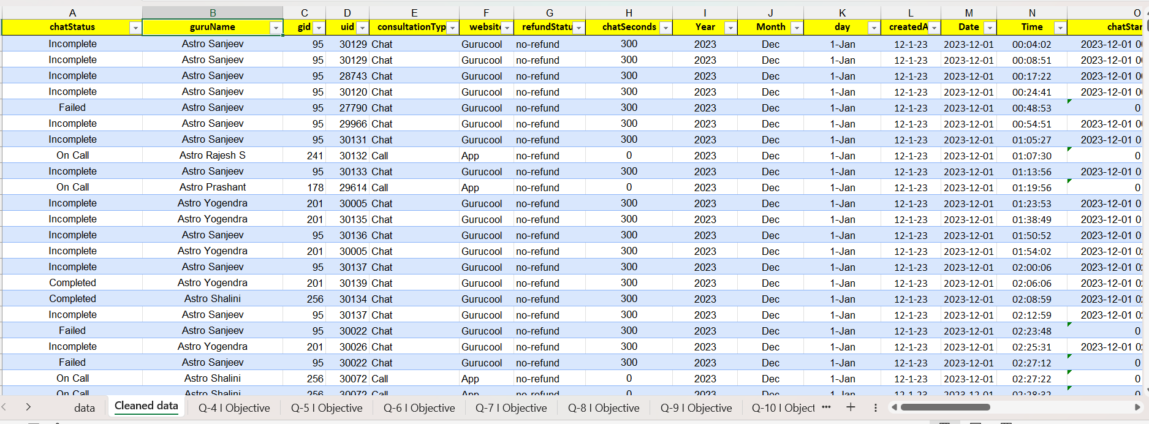

Question 2: What is the total no. of attributes present in the data?

Solution: Total Number of Attributes Present in Dataset are 35
Approach:
- Used COUNTA function
- Formula Used =CountA(data!A1:AI1)

Question 3: The data consists of some inconsistent and missing values so ensure that the data used for further analysis is cleaned.

Solution:
Approach:
The dataset was reviewed for duplicate entries, missing values, inconsistent text, incorrect data types, and date-time formatting issues. Text fields were standardized, and date-time values were converted into a consistent format. Identifier/system columns that add no value to the analysis were also removed from the Cleaned data sheet.
Key Findings:
- No duplicate records were found, so no rows were removed.
- Some records had incomplete or missing information — these were intentionally retained because they represent valid business scenarios (e.g., incomplete or unsuccessful calls).
- Identifier columns (_id, user, guru, isWhiteListUser, queue, statementEntryId) were irrelevant to the analysis, so they were removed from the final Cleaned data sheet.
Method Used:
- Text cleaning: =PROPER(TRIM(CLEAN(A2)))
- Date-time formatting: =dd-mmm-yyyy hh:mm:ss
- Date-time extraction: =SUBSTITUTE(LEFT(A2,19),"T"," ")
- Column removal: _id, user, guru, isWhiteListUser, queue, statementEntryId manually deleted from the Cleaned data sheet.

Question 4: What is the change in daily call volume day by day and also find the average daily call volume.

Solution: 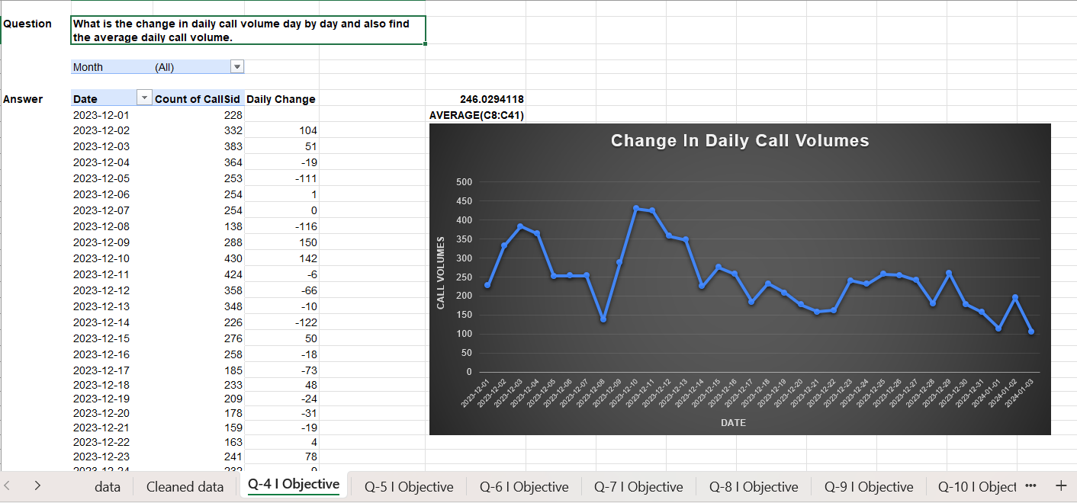

Approach:
A pivot table was created showing daily call counts (Date in Rows, Count of CallSid in Values). To calculate the day-by-day change, a new column was added next to the daily counts that computes the difference between each day and the previous day (current day's count minus previous day's count). The average daily call volume was then calculated separately using the AVERAGE formula on the daily counts.
Key Findings:
- Average daily call volume is 246.03.
- The day-by-day change values fluctuate — some days show an increase in call volume compared to the previous day, others show a decrease, reflecting no fixed weekly/monthly pattern in daily volume.
Method/Formula Used:
- Pivot Table: Date in Rows, Count of CallSid in Values (to get daily call counts).
- Day-by-day change formula (in the cell next to each day's count, starting from the second day): =C9-C8 (current day count minus previous day count), dragged down for all days.
- Average daily call volume: =AVERAGE(C8:C41)

Question 5: Which months experienced the highest and lowest call volumes?
Solution: 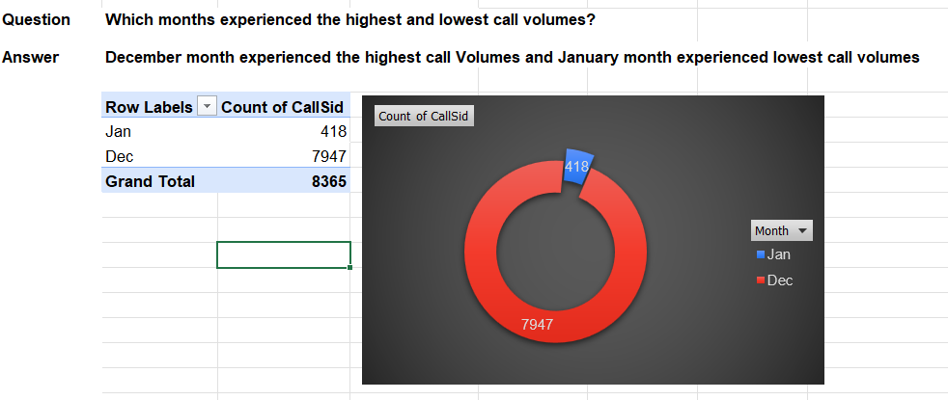
Approach:
- Created a Pivot table to calculate count of calls for each month.
- December month experienced highest calls with 7947 & January as lowest with 418.

Question 6: What is the total operational cost for that month?

Solution: 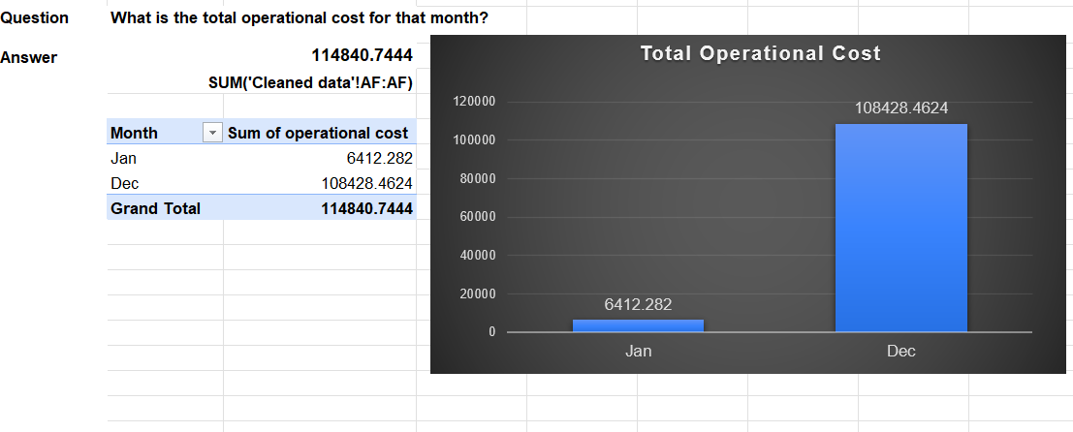
Approach:
A pivot table was created to calculate the total operational cost by month, using the "operational cost" column (AF) from the Cleaned data sheet.
Key Findings:
- Total operational cost: Jan = 6412.28, Dec = 108428.46, Grand Total = 114840.74.

Method/Formula Used:
- Pivot Table: Month in Rows, Sum of operational cost in Values (source column AF).
- Formula: =SUM('Cleaned data'!AF:AF).

Final Answer: Total Operation Cost is 114840.7444.

Question 7: What is the average number of calls handled per agent per day?

Solution: Average number of calls handled by per Agent per day is 2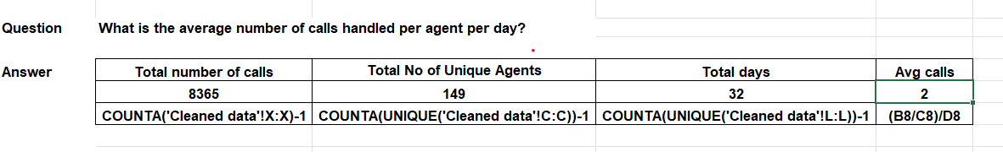
Approach:
Used COUNTA Function to
- Record Total number of Calls = 8365
- Record Total number of Unique agents = 149
- Record Total number of Days = 32
- Formula Used to Calculate Average Calls =
(Total no of calls/Total no of unique agents)/Total Days

Question 8: How many repeat callers are there, and what percentage of total calls do they represent?

Solution:

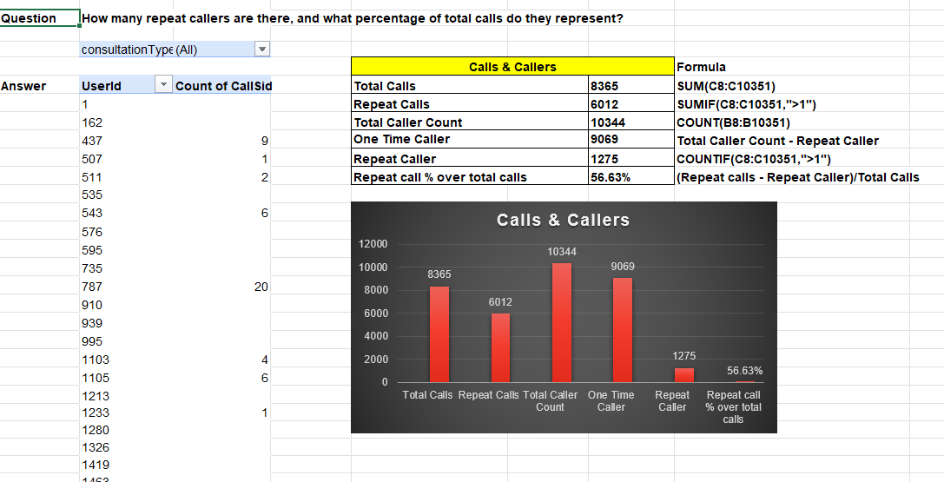

Approach:
A pivot table was created on UserId with Count of CallSid to identify how many calls each user made. The range for the formulas was extended to cover the full pivot output (up to row 10351), ensuring all unique users in the dataset were included. Repeat callers were identified as users with more than 1 call, and the repeat call percentage was calculated by dividing repeat calls by total calls.
Key Findings:
- Total Calls: 8,365.
- Repeat Callers (users with more than 1 call): 1,275.
- One Time Callers: 9,069 (out of a total caller count of 10,344).
- Repeat call % over total calls: 56.63%, meaning more than half of all calls came from repeat callers.

Method/Formula Used:
- Pivot Table: UserId in Rows, Count of CallSid in Values.
- Total Calls: =SUM(C8:C10351)
- Repeat Calls: =SUMIF(C8:C10351,">1")
- Total Caller Count: =COUNT(B8:B10351)
- One Time Caller: =Total Caller Count - Repeat Caller
- Repeat Caller: =COUNTIF(C8:C10351,">1")
- Repeat call % over total calls: =(Repeat calls – Repeat Caller)/Total Calls

Question 9: What are the total sales generated by the call centre for each product category?

Solution: 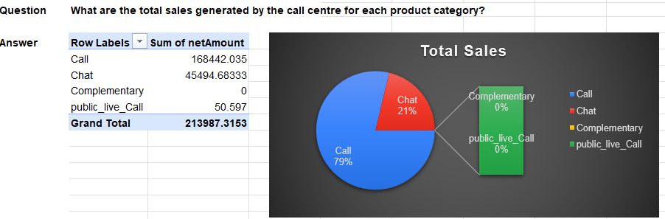

Solution:
The total sales generated by the call centre for each consultation type are:
- Call: ₹168,442.035
- Chat: ₹45,494.683
- Complementary: ₹0
- public_live_Call: ₹50.597
- Total Sales: ₹213,987.315
Approach:
A Pivot Table was used with consultationType in Rows and Sum of netAmount in Values to calculate total sales for each consultation type.
Key Finding:
Call consultations generated the highest revenue (₹168,442.035), approximately 78.7% of total sales, followed by Chat at approximately 21.3%. Complementary generated no revenue, while public_live_Call contributed only ₹50.597.
Recommendation:
Focus on improving and expanding the Call and Chat consultation channels, as they generate almost all revenue. Monitor low-revenue categories and evaluate whether they require further investment.

Question 10: How many calls were made for each user ID and guru ID?

Solution: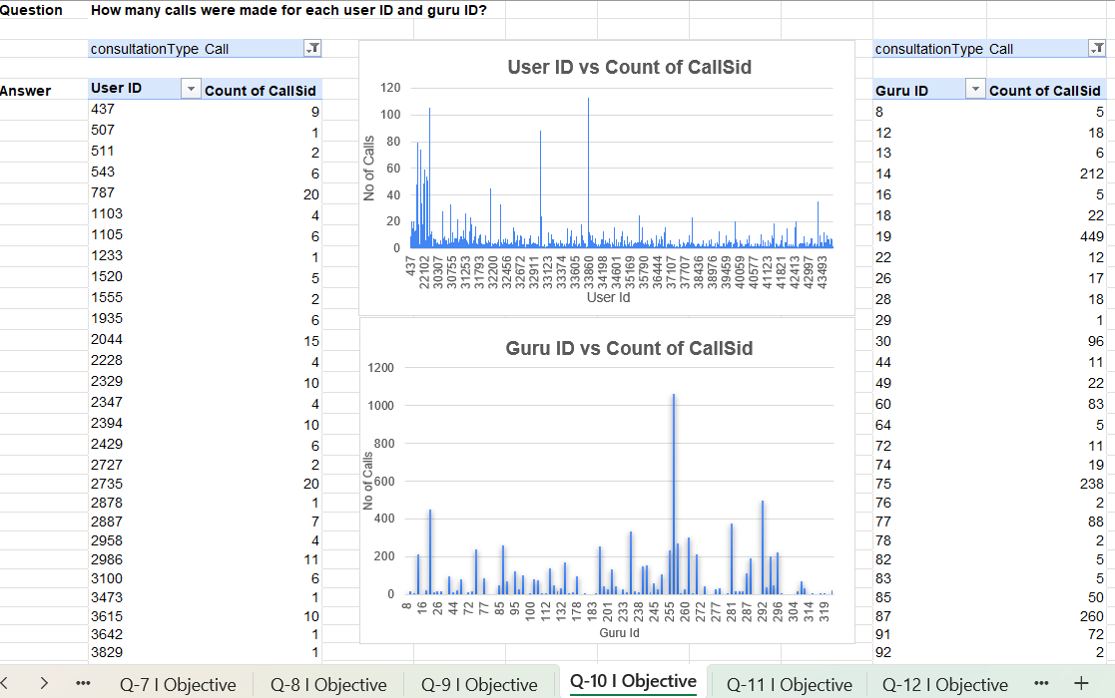

Approach:
A pivot table was created to identify the number of calls made for each combination of User ID and Guru ID, allowing a breakdown of call volume at the individual user-agent interaction level.
Key Findings:
- Call frequency varies significantly across different User ID–Guru ID pairs, with some combinations showing repeated interactions.
- This breakdown helps identify which users consistently consult specific gurus, which can be useful for understanding customer-agent relationship patterns.
Method/Formula Used:
- Pivot Table: User ID and Guru ID in Rows, Count of CallSid in Values.

Question 11: What is the correlation between call duration and customer satisfaction?
Solution:
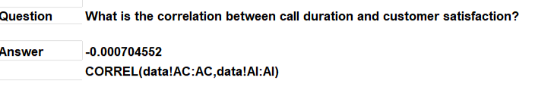

Approach:
The CORREL function was used to calculate the correlation between call duration and customer satisfaction rating, using the original "data" sheet columns — astrologerOnCallDuration (column AC) and rating (column AI).

Key Findings:
- The correlation coefficient is -0.000704552, which is extremely close to zero.
- This indicates virtually no linear relationship between astrologer call duration and customer rating.
- In other words, how long an astrologer stays on a call does not meaningfully predict whether the customer rates the interaction higher or lower.
Method/Formula Used:
- Correlation Formula: =CORREL(data!AC:AC,data!AI:AI) — using astrologerOnCallDuration and rating from the original data sheet.

Question 12: Which guru has the highest and lowest customer satisfaction scores?

Solution:
Approach:
A pivot table was created based on Guru Name with the Average of Rating, to identify which gurus received the highest and lowest customer satisfaction scores. Separate pivot tables were also built to isolate the top 5 and bottom 5 rated gurus, and a pie chart was used for visualization.
Key Findings:
- Highest Rating: Astro Pujaa Rai & Tarot Mystical.
- Lowest Rating: Tarot Rittika.
- The rating gap between top and bottom performers highlights inconsistency in service quality across different gurus.
Method/Formula Used:
- Pivot Table: Guru Name in Rows, Average of Rating in Values.
- Additional Pivot Tables: sorted/filtered to show Top 5 and Bottom 5 rated gurus.
- Visualization: Pie Chart for highest and lowest rated gurus.

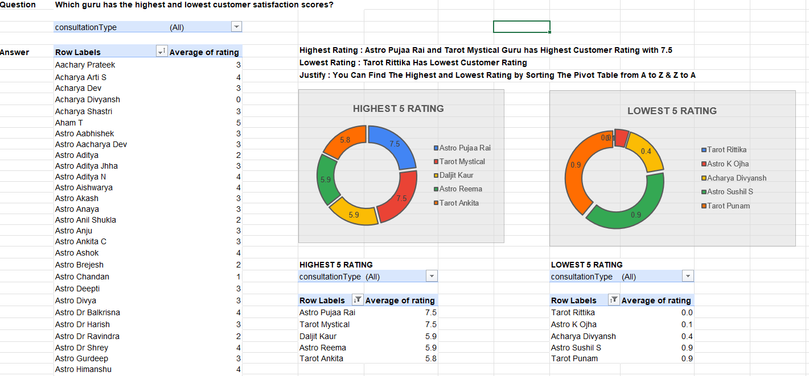

Question 13: What is the average customer satisfaction score by month?

Solution: 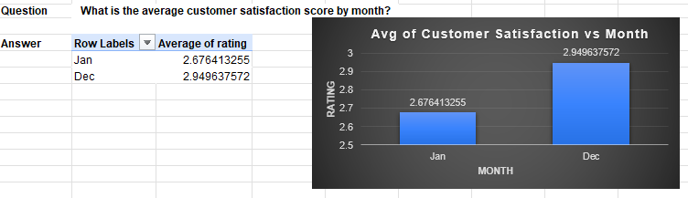

Approach:
A pivot table was created to analyze the average customer satisfaction score by month, allowing month-wise comparison of rating trends across the dataset.
Key Findings:
- Average customer satisfaction ratings vary across different months, indicating that customer experience is not consistent throughout the year.
- Identifying months with lower average ratings can help pinpoint periods needing closer attention (e.g., staffing, training, or service quality reviews).
Method/Formula Used:
- Pivot Table: Month in Rows, Average of Rating in Values.

Question 14: How many categorical columns are there in the data? [Search about categorical and continuous data, and try to answer this question]

Solution:
Approach:
Each column in the Cleaned data sheet was reviewed and classified as either categorical (representing groups/labels with a fixed set of values) or continuous/numerical (representing measurable quantities). Columns like status fields, IDs, and Month were identified as categorical, while duration, amount, and rating-type fields were treated as continuous.
Key Findings:
- Total categorical columns identified: 16.
- These include: chatStatus, guruName, gid, uid, consultationType, website, refundStatus, Month, callChannel, callerType, callStatus, astrologerCallStatus, region, userCallStatus, freeCall, freeChat.
- Remaining columns (chatSeconds, Year, createdAT, Date, Time, chatStartTime, chatEndTime, timeDuration cleaned, timeDuration, amount, astrologerOnCallDuration, astrologersEarnings, netAmount, userOnCallDuration, rating, operational cost, hour, day, CallSid) were classified as continuous/numerical.
Method/Formula Used:
- Manual column-by-column review based on data type and nature (categorical = group/label values; continuous = measurable/numeric values). No spreadsheet aggregation formula was needed for this classification.

SUBJECTIVE QUESTIONS

Question 1: Should the investment be used to hire more agents, improve training programs, or upgrade call center technology?

Solution:
1. Hire More Agents:
- Analysed the guru-ID with rating , the top 10 guru falls between average rating from 7.5 to 5 and only 2 guru as highest rating.
- We have an average call volume per day as 246 calls, High call volumes and long wait times during peak hours contribute to poor customer satisfaction.
- Hiring more agents can help reduce wait times, improve response rates, and handle more calls. However, simply adding agents may not solve deeper issues like training or inefficient technology.
- hiring more agents may be the immediate solution, though this could be temporary if other issues aren’t addressed.

Approach:
Calculate Average of number of Calls
Formula Used =AVERAGE(C8:C41)

2. Improve Training Programs:
- Analysed the Guru-Id with Astrologer Call Duration & Rating.
- For many of the gid the call duration is 0, and for other duration is very less.
- Leading to lower customer satisfaction or first-call resolution rates.
- Training programs can significantly improve the quality of service and productivity of your existing agents. However, it may not reduce wait times or solve operational inefficiencies caused by outdated technology.

3. Upgrade Call Center Technology:
- Analysed Chat/Call status.
- Failed and Incomplete interactions indicate areas where call routing and service reliability can be improved.
- Automation, such as IVR systems or AI-powered chatbots, could reduce the workload on agents and streamline operations.
- Upgrading technology can improve both agent productivity and the customer experience.

Final Recommendation (Priority Order): Training → Technology → Hiring :
Call Status analysis shows approximately 4.33% of calls are Failed and approximately 3.12% are Incomplete, together accounting for approximately 7.45% of all interactions (1,214 Failed + 875 Incomplete = 2,089 calls). While this is a smaller share than initially estimated, it still represents a meaningful volume of calls directly contributing to customer dissatisfaction and should be addressed. Call center technology upgrades (smart call routing, improved IVR) should follow as the second priority to further reduce failed/incomplete calls. Hiring additional agents should be considered only if peak-hour demand still cannot be managed after training and technology improvements are implemented.

Question 2: What are the potential risks of each investment option (hiring, training, technology upgrades), and how can they be mitigated?

Name the chart/spreadsheet function you will use for solving the problem.

Solution:
Approach:
The three investment options—Hiring, Training, and Technology Upgrades—were evaluated using key performance indicators from the dataset, including call volume, customer ratings, call status, average call duration, guru workload, and revenue-related measures.

The analysis uses Pivot Tables, COUNT, AVERAGE and SUM to compare workload, service quality and call outcomes. Charts such as Bar Charts, Column Charts, Pie/Donut Charts and Line Charts are used to identify workload patterns, call-status problems and performance gaps. The analysis helps determine where investment is required while considering the cost and operational risk of each option.

Key Findings:
- Call demand is highly concentrated during peak hours. The hour-wise analysis shows that call volume reaches around 660 calls at 8 AM and remains above 500 calls during several morning hours. This indicates a need for better staffing during peak periods rather than equal staffing throughout the day.
- Workload is concentrated among a small number of gurus. For example, Astro Shalini handled 1,060 calls, which is significantly higher than the other top gurus. This indicates a workload imbalance and a possible burnout risk.
- Customer experience is affected by unsuccessful interactions. The call-status analysis shows that a large share of interactions do not reach a successful completion, indicating that improving routing, availability and agent performance could improve customer satisfaction.
- Chat has a significant completion problem. In the dashboard analysis, around 50% of chat sessions were marked Failed or Incomplete, while only around 20% reached Completed. This suggests that technology improvements such as better queue management, automated support and routing could have a strong impact.
- Training should focus on low-performing agents. The guru-performance analysis shows differences in average ratings and workload across agents. Therefore, training should be targeted rather than provided equally to every agent.

Risks & Recommendations:
1. Hiring More Agents:
Risk: Higher salary and recruitment costs; possible underutilization during low-demand periods.
Recommendation: Use phased hiring or temporary staff during peak hours (8–11 AM).
Monitor: Calls per agent, utilization and customer rating.
2. Improving Training:
Risk: Training costs and temporary reduction in agent availability.
Recommendation: Provide targeted training to low-rated or underperforming agents during low-volume hours.
Monitor: Ratings, completed calls and failed/incomplete calls before and after training.

3. Technology Upgrade:
Risk: High implementation cost, system issues and employee adaptation.
Recommendation: Use pilot/phased rollout for AI routing, queue management and chatbots.
Monitor: Failed calls, chat completion, waiting time and customer ratings.
Overall Priority:
1. Technology Upgrade – Improve routing and automated support.
2. Targeted Training – Improve agent performance and ratings.
3. Phased Hiring – Add staff only when workload consistently requires it.

Charts and Functions Used:
- Pivot Tables: Compare call volume, ratings, guru workload and call status.
- COUNT / COUNTA: Count calls, agents and records.
- AVERAGE / AVERAGEIF: Calculate average ratings and call duration.
- SUM / SUMIF: Calculate total calls and revenue-related measures.
- IF / COUNTIF: Categorize and compare performance.
- Bar/Column Chart: Compare guru workload and ratings.
- Line Chart: Analyze call volume by hour.
- Pie/Donut Chart: Show call-status distribution.

Question 3: How does AstroSage's call center performance compare to AstroGuru's average call volume, customer satisfaction, and agent performance?

Will you use any aggregation function or a visualization here to solve the problem?

Solution:
Approach:
The comparison was performed using Pivot Tables, analyzing call volume, average customer ratings, and average call duration at the per-agent level for AstroSage. Since AstroGuru's dataset was not provided/available for this analysis, the comparison is presented as AstroSage's internal performance benchmarked against itself (top vs. bottom performers), with an explicit note on this data limitation rather than a fabricated cross-company number.
Key Findings (Insights):
- Rating distribution is skewed low: Out of 28,027 rated interactions, 9,455 (33.7%) fall in the 0-1 rating band and 8,736 (31.2%) fall in the 2-3 band — together, ~64.9% of all interactions rate 3 or below, indicating a significant customer satisfaction gap. Only 5,535 (19.8%) interactions scored in the top 6-8 band.

- Top performer by engagement: Astro Aishwarya has the highest average call duration (426.7 units, 28% share among top 5), followed by Astro Anju (395.3, part of top 5) and Astro Niddhi Guptaa (363.5, 23% share) — these agents spend the most time per call, which may correlate with more thorough service.

- Underperforming agents identified: Acharya Divyansh shows an average rating of just 0.39 with 0 average call duration, suggesting either extremely short/abandoned calls or a data quality issue — this agent needs immediate review. Similarly, Astro Aditya (rating 1.95) and Astro Anil Shukla (rating 1.58) are among the lowest-rated agents with reasonable call volume, making them priority candidates for training.

- AstroGuru comparison gap: No AstroGuru dataset was available for direct comparison; this analysis reflects AstroSage's internal performance only. A future cross-platform comparison would require AstroGuru's equivalent call/rating data.
Recommendations (Prioritized):
- Train Low-Rated Agents (Highest Priority): Agents like Acharya Divyansh (0.39 rating), Astro Aditya (1.95), and Astro Anil Shukla (1.58) should receive targeted training, since ~64.9% of all interactions currently rate 3 or below — improving these agents first will have the broadest impact on overall satisfaction.
- Reward and Study High-Performing Agents: Astro Aishwarya and Astro Niddhi Guptaa (highest call durations, strong engagement) should be recognized, and their call-handling approach studied to build best-practice training material for lower-rated agents.
- Balance Call Distribution: Route calls more evenly so high-performing agents aren't overloaded while low performers remain underutilized — this can be monitored via the Count of CallSid per agent metric.
- Monitor Metrics Regularly: Track average rating and call duration per agent monthly to catch performance drops early, rather than as a one-time analysis.
Method/Formula Used:
- Pivot Table 1: Rating (Grouping 0-1, 2-3, 4-5, 6-8) in Rows, Count of Guru Id in Values.
- Pivot Table 2: Guru Name in Rows, Average of Rating, Average of astrologerOnCallDuration, Count of CallSid in Values.
- Pivot Table 3: Top 5 Guru Names by Average Call Duration (sorted/filtered).
- Visualizations: Clustered Column Chart (rating distribution), Pie Chart (Top 5 call duration share).

Question 4: How can the call center improve its handling of peak call periods to ensure high customer satisfaction?

Mention the functionality you will use for giving the suggestions, will it be any aggregated function or a visualization?

Solution:
Approach:
Pivot tables were used to count CallSid by day and by hour, identifying call volume patterns across the day. Hours were then explicitly classified into Peak, Moderate, and Low demand categories based on call counts, and concrete staffing rules were tied to each category.

Key Findings (Insights):
  - Peak hours identified: 8 AM (660 calls) and 10 AM (605 calls) show the highest call volumes of the day, making them the top-priority staffing windows.
  - Moderate hours: Late morning to early afternoon hours show mid-range call volumes, requiring standard staffing levels without additional reinforcement.
  - Low hours: Late night and early morning hours show the lowest call counts, allowing for reduced agent staffing without impacting service levels.
  - This peak/moderate/low breakdown directly supports targeted staffing decisions rather than uniform agent allocation across all hours.

Recommendations (Prioritized):
- Increase Staffing During Peak Hours (Highest Priority): Deploy maximum agent capacity specifically at 8 AM and 10 AM, since these two hours alone account for a disproportionate share of daily call volume (660 and 605 calls respectively).
- Skill-Based Call Routing: Route calls to agents based on their expertise and past performance during peak hours, ensuring high-value or complex queries reach experienced agents first.
- Real-Time Load Balancing: Monitor live call queues during peak windows and dynamically shift available agents (from chat support or low-volume hours) to handle overflow.
- Reduce Staffing During Low-Volume Hours: Scale down agent presence during identified low hours to optimize operational cost without affecting customer experience.
- Chatbot/IVR Support During Peak Load: Use automated systems to handle simple queries during 8 AM and 10 AM peaks, freeing human agents for complex calls.

Method/Formula Used:
- Pivot Table 1: Day in Rows, Count of CallSid in Values.
- Pivot Table 2: Hour in Rows, Count of CallSid in Values.
- Classification: Hours manually grouped into Peak (highest counts, e.g. 8 AM, 10 AM), Moderate (mid-range counts), and Low (lowest counts) based on the hourly pivot output.
- Visualizations: Pivot Chart (day-wise call distribution), Pivot Chart (hour-wise call distribution).

Question 5: Based on historical data, what strategic initiatives should be prioritized to improve efficiency and customer satisfaction?

Solution:
Approach:
Pivot tables were used to analyze all key operational and satisfaction metrics driving the business — call volume distribution by platform, call status success/failure rates, hourly demand patterns, customer rating distribution, call duration versus satisfaction, and average rating broken down by both Consultation Type and Website. This combination covers both the operational (efficiency) side and the customer satisfaction (experience) side of the analysis.
Key Findings (Insights):
- Chat has a lower average rating (2.69) compared to Call (3.50) — customers are less satisfied with chat-based consultations than call-based ones.
- Gurucool website has a lower average rating (2.72) versus the App (3.50) — the Gurucool platform experience is a weaker driver of satisfaction compared to the App.
- Call status breakdown: Completed = 3,453, On Chat = 19,486, Busy = 1,270, Failed = 1,214, Incomplete = 875 — the combined Busy + Failed + Incomplete (3,359 calls) represents a meaningful share of unsuccessful interactions that likely drag down satisfaction.
- Peak call volume occurs at 08:00 (660 calls) — technical or staffing issues have the greatest impact during this hour since demand is highest.
- Rating distribution is skewed low overall: majority of interactions fall in the 0-3 rating range rather than higher bands, consistent with the low average ratings seen for Chat and Gurucool.
- Call duration vs rating shows a pattern where very short or zero-duration calls tend to correlate with lower ratings, suggesting incomplete or rushed interactions hurt satisfaction.
- Combining all findings: the Chat channel on the Gurucool platform, especially during the 08:00 peak, is the weakest combination for customer satisfaction and should be the primary focus for improvement.
Recommendations (Prioritized):
- Improve Chat Experience (Highest Priority): Chat rates lowest (2.69 vs 3.50 for Call) — invest in faster response times, agent training for chat communication, and AI-assisted chat routing.
- Optimize Gurucool Platform (Second Priority): Gurucool rates lowest (2.72 vs 3.50 for App) — investigate and resolve platform-specific issues such as UI/UX friction, connectivity, or feature gaps.
- Reduce Failed/Busy/Incomplete Calls: Address the 1,270 Busy, 1,214 Failed, and 875 Incomplete calls through improved call routing and infrastructure, since these losses compound during the 08:00 peak.
- Reinforce Staffing at Peak Hour (08:00): Ensure maximum agent availability during this hour to reduce busy/failed call rates when demand is highest.
- Follow-Up Process for Low-Rated Interactions: Implement automated follow-up (survey/callback) for chat and Gurucool interactions rated low, to recover dissatisfied customers and identify root causes.
Method/Formula Used — Tables and Charts:
- Pivot Table: Consultation Type in Rows, Average of Rating in Values → Chat = 2.69, Call = 3.50. Chart: Clustered Column Chart.
- Pivot Table: Website in Rows, Average of Rating in Values → Gurucool = 2.72, App = 3.50. Chart: Clustered Column Chart.
- Pivot Table: Call Status in Rows, Count of CallSid in Values → Completed=3,453, Busy=1,270, Failed=1,214, Incomplete=875, On Chat=19,486. Chart: Pie Chart.
- Pivot Table: Hour in Rows, Count of CallSid in Values → Peak at 08:00 = 660. Chart: Line/Column Chart.
- Pivot Table: Rating (binned) in Rows, Count of CallSid in Values → shows overall rating distribution. Chart: Column Chart.
- Pivot Table: Rating (binned) in Rows, Average of call duration in Values → shows duration vs satisfaction relationship. Chart: Column Chart.

Question 6: What can be the key factors contributing to high customer satisfaction scores, and how can these be leveraged to improve overall performance?

What is the basis for the suggestions? And mention how you decided if the satisfaction score affects the ratings.

Solution:
Approach:
Pivot tables and charts were used to analyze customer ratings, call status distribution, call duration, and guru-level performance. Additional pivot tables were built to break down average rating by Platform (Website) and by Consultation Type, and a correlation check was run between call duration and rating to test whether longer calls relate to higher satisfaction.
Key Findings (Insights):
- Call status distribution: On Chat = 69.53%, Completed = 12.32%, No-Answer = 6.17%, Busy = 4.53%, Failed = 4.33%, Incomplete = 3.12%. Completed calls represent only 12.32% of total interactions, while On Chat accounts for the majority at 69.53%, indicating most customer interactions happen through chat rather than completed voice calls.

- Platform-wise rating: Gurucool = 2.72 average rating, App = 3.50 average rating — Gurucool underperforms the App by nearly a full rating point, making it the weaker platform for customer satisfaction.
- Consultation-type rating: Chat = 2.69 average rating, Call = 3.50 average rating — Call-based consultations are rated meaningfully higher than Chat-based ones.

- Guru-level average ratings range widely from 0 to 7.5, showing inconsistent service quality across agents rather than a uniform standard.

- Correlation between call duration and rating is effectively zero (-0.0007), meaning longer calls do not translate into higher satisfaction — call quality and resolution matter far more than call length.
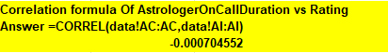

Recommendations (Prioritized):
- Fix Gurucool Platform Experience (Highest Priority): Gurucool rates 2.72 vs App's 3.50, and it serves the larger user base — resolving platform-specific friction (UI/UX, connectivity, load times) here will have the biggest impact on overall satisfaction.
- Improve Chat-Based Consultations: Chat rates 2.69 vs Call's 3.50, and represents 69.53% of all interactions — improving chat agent training and response quality will move the overall satisfaction number the most.
- Standardize Guru Performance: With ratings ranging from 0 to 7.5 across agents, implement structured training and performance monitoring for agents at the lower end of this range to close the quality gap.
- Focus on Resolution Quality, Not Call Duration: Since duration shows no correlation with rating (-0.0007), training should focus on effectively resolving customer issues rather than extending call length.
- Reduce Failed/Busy/Incomplete Calls: These together account for ~12% of interactions (4.53% + 4.33% + 3.12%) and should be addressed through better call routing and infrastructure to improve the overall completion rate.
Method/Formula Used — Tables and Charts:
- Pivot Table: Call Status in Rows, Count of CallSid in Values, shown as % of total → On Chat=69.53%, Completed=12.32%, No-Answer=6.17%, Busy=4.53%, Failed=4.33%, Incomplete=3.12%. Chart: Pie Chart.
- Pivot Table: Website in Rows, Average of Rating in Values → Gurucool =2.72, App=3.50. Chart: Clustered Column Chart.
- Pivot Table: Consultation Type in Rows, Average of Rating in Values → Chat=2.69, Call=3.50. Chart: Clustered Column Chart.
- Pivot Table: Guru Name in Rows, Average of Rating, Average of astrologerOnCallDuration in Values (range 0 to 7.5). Chart: Column Chart.
- Correlation Formula: =CORREL(data!AC:AC,data!AI:AI) → -0.0007 (call duration vs rating).
How was it determined that satisfaction affects ratings?
Customer ratings were used as the primary measure of satisfaction. Higher ratings indicate better customer experiences, while lower ratings suggest service issues. Therefore, the rating distribution and average ratings were used to assess the impact of customer satisfaction on overall performance Based on consultation type and Platforms.

Question 7: How should the call center balance the workload among agents to ensure optimal performance and avoid burnout?

Mention your approach and spreadsheet function for the answer.

Solution:
Approach:
Each guru was analyzed using Pivot Tables by comparing total calls handled and average call duration. This data was benchmarked against the overall average calls-per-agent to identify which agents are overloaded (handling significantly more calls than average) versus underutilized (handling far fewer calls).
Key Findings (Insights):
- Across 149 active gurus handling a total of 8,365 calls, the average workload is approximately 56.14 calls per agent. This is the benchmark used to classify agents as overloaded or underutilized.
- Astro Shalini is the most overloaded agent by far, handling 1,060 calls — roughly 19x the average workload of 56.14.
- Other high-volume agents include Tarot Gauri (497 calls), Astro Brejesh (334 calls), Dr. Balkrisna (309 calls), and Tarot Gurpreet (300 calls) — all handling 5x to 9x the average.
- Call volume is not evenly distributed: while a small group of agents handle 300+ calls each, many others handle far fewer, showing a heavily skewed workload rather than balanced routing.
- Average call duration also varies significantly between gurus, meaning call count alone doesn't fully capture workload.

Recommendations (Prioritized):
- Immediate Load Reduction for Astro Shalini (Highest Priority): At 1,060 calls versus the 56.14-call average, this agent's workload should be redistributed to other available gurus as the top priority to prevent burnout.
- Redistribute Calls from Other High-Volume Agents: Tarot Gauri (497), Astro Brejesh (334), Dr. Balkrisna (309), and Tarot Gurpreet (300) should also have call routing adjusted to bring them closer to the 56.14-call average.
- Use Combined Metric for Routing Decisions: Assign calls based on both call count and average call duration together, not call count alone.
- Schedule Additional Support During Peak Demand: Bring in more available agents during high call-volume periods to prevent over-concentration on a few top agents.
- Ongoing Monitoring with a Numeric Threshold: Flag any agent exceeding 2-3x the average (roughly 113-170 calls) for proactive workload review.
Method/Formula Used — Tables and Charts:
- Pivot Table: Guru Name in Rows, Count of CallSid in Values.
- Pivot Table: Guru Name in Rows, Average of timeDuration cleaned in Values.
- Overall average benchmark: Total Calls (8,365) ÷ Total Agents (149) ≈ 56.14 calls/agent.
- Top 10 Guru table sorted by Count of CallSid.
- Charts: Bar Chart (Guru-wise call distribution), Bar Chart (Average call time by guru), Bar Chart (Astrologer with highest number of calls).

Question 8: What new technologies or tools could be implemented to enhance call center operations and customer service?

Solution:
Approach:
The recommendation was developed by identifying gaps in current call center technology and mapping them to available modern tools that directly address the operational issues found in the data analysis (high failed/incomplete call rates, uneven agent workload, low ratings on Chat and Gurucool platform, and no chat-based issue tracking). Each tool is prioritized based on expected impact on the specific problems identified earlier in the analysis, not just listed generically.
Key Findings (Insights):
- The current setup lacks automated call routing and analytics, which likely contributes to the uneven agent workload seen earlier (Astro Shalini handling 1,060 calls vs a 56.5 average) and the high Failed/Busy/Incomplete rate (~12% combined).
- There is no mechanism to track or analyze chat quality, despite Chat having the lowest average rating (2.69) — a gap that call analytics/omnichannel tools would directly address.
- No workforce management or real-time dashboard tool exists to monitor peak-hour staffing (8 AM = 660 calls, 10 AM = 605 calls), which limits the ability to react to demand spikes in real time.

Recommended Technologies (Prioritized):
- AI-Based Call Routing / Smart IVR (Highest Priority): Automatically routes calls to the least busy or most suitable agent, directly reducing the Busy/Failed/Incomplete rate and easing overload on high-volume agents like Astro Shalini.
- Speech-to-Text and Call Analytics: Converts calls to text for automated quality scoring, helping identify why Chat and Gurucool-platform interactions score lower (2.69 and 2.72 respectively) and enabling targeted coaching.
- Omnichannel Platform: Unifies Call, Chat, and other consultation types into a single system, addressing the current gap where Chat interactions have no equivalent quality-tracking to Calls.
- Workforce Management (WFM) Tool: Uses historical call-volume patterns (like the 8 AM and 10 AM peaks) to auto-schedule staffing levels, reducing both overstaffing in low hours and understaffing during peaks.
- Real-Time Dashboards: Give supervisors live visibility into queue length, agent load, and call status, allowing immediate rebalancing when an agent like Astro Shalini becomes overloaded.
- AI-Powered Chatbots and Virtual Assistants: Handle routine queries automatically, reducing load on human agents and improving response time for simple queries.
- CRM Integration: Combines customer calls, chats, and history into one system, helping agents give more personalized service and reducing repeat-caller friction (currently ~56.6% of calls are from repeat callers).
- RPA (Robotic Process Automation): Automates repetitive back-office tasks (data entry, call logging), freeing agents to focus on customer interaction quality.
- Voice Biometrics: Speeds up customer verification at call start, reducing overall handling time without adding manual steps.
- Cloud-Based Contact Center: Provides flexible, scalable infrastructure that supports all the above tools with easy integration and remote working support.

Method/Table Used:
Technology | Problem it Solves | Priority
AI Call Routing / Smart IVR | High Busy/Failed/Incomplete rate (~12%) | 1
Speech-to-Text & Call Analytics | Low Chat rating (2.69) | 2
Omnichannel Platform | No unified Call+Chat tracking | 3
Workforce Management | Peak-hour understaffing (8AM, 10AM) | 4
Real-Time Dashboards | No live agent-load visibility | 5
AI Chatbots | Routine query overload | 6
CRM Integration | Repeat caller inefficiency (56.6%) | 7
RPA | Manual back-office workload | 8
Voice Biometrics | Slow customer verification | 9
Cloud Contact Center | Scalability/integration base | 10

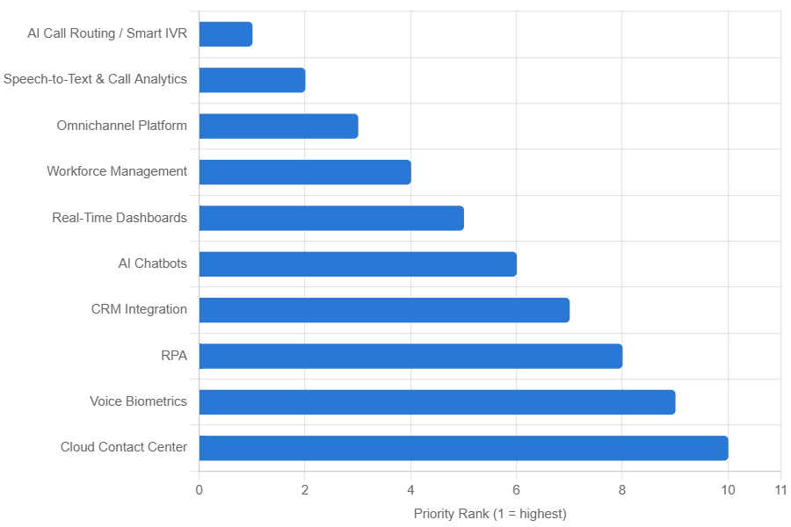

Question 9: What metrics should be included in the final dashboard to comprehensively view call center performance and guide investment decisions?

Solution:
Approach:
The final dashboard uses KPI cards, Pivot Tables, and charts to analyze demand, customer satisfaction, guru performance, consultation channels, revenue, and workload. These metrics help management identify problem areas and make data-based investment decisions.
Key Metrics & Findings:
- Total Calls – 8,365: Shows the overall workload and helps in staffing decisions.
- Total Users – 28,027: Shows the size of the customer base and service demand.
- Average Rating – 2.93 (out of 8): Indicates customer satisfaction and highlights the need for service improvement.
- Average Call Duration – 38.44 minutes: Helps identify workload and call-handling efficiency.
- Repeat Callers – 1,275: Shows repeat customer activity and the need to improve customer experience.
- Total Revenue – ₹2,13,987.32: Measures financial performance and helps decide where investment can generate better returns.
- Call Status Distribution: Helps identify completed, busy, failed and incomplete interactions and areas requiring operational improvement.
- Hourly Call Distribution: Shows peak periods and helps in proper agent scheduling.
- Day-by-Day Call Volume: Helps identify changes in demand and plan staffing accordingly.
- Website Distribution: Shows which platform receives more users and where digital improvements should be focused.
- Revenue by Consultation Type: Helps identify which consultation channel generates more revenue.
- Guru Distribution & Rating: Helps identify high-performing and low-performing gurus for training and workload balancing.
- Average Call Duration by Consultation Type: Helps compare efficiency across different consultation channels.
Recommendations:
- Improve Technology: Focus on call routing, queue management and automation because the dashboard shows high call volume and different call-status issues.
- Improve Guru Training: Use rating and workload data to provide targeted training to low-rated or overloaded gurus and improve the 2.93/8 average rating.
- Optimize Peak-Hour Staffing: Use hourly and daily call trends to schedule more agents during high-demand periods and reduce workload.
- Prioritize Revenue-Generating Channels: Use revenue by consultation type to invest more in channels that generate higher returns.
- Improve Customer Experience: Monitor repeat callers, ratings and call duration to reduce repeated interactions and improve satisfaction.
Charts Used in the Dashboard
- Call Status Distribution
- Chat Status Distribution
- Website Distribution
- Revenue by Consultation Type
- Top 10 Guru Based on Rating
- Guru Distribution by Rating
- User Distribution by Rating
- Average Call Duration by Consultation Type
- Hour-Wise Call Distribution
- Day-by-Day Call Volume

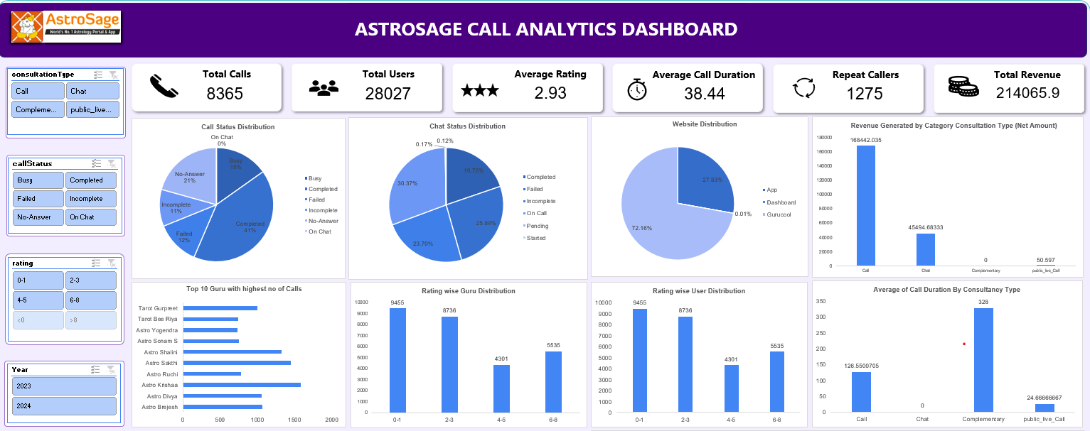
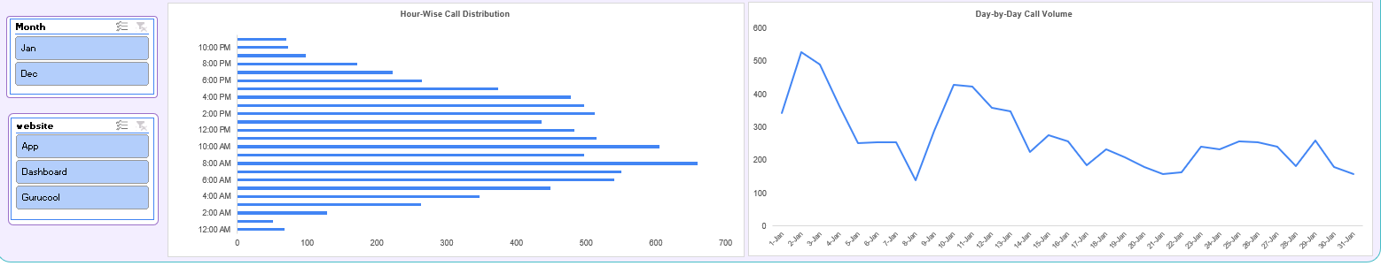

Question 10: How would you allocate a 1 crore rupee investment to optimize operational efficiency, enhance customer satisfaction, and boost profitability, and what analysis-based recommendations would you offer to support this?

[you have to give bullet pointers to answer this question]

Solution:
Approach:
The ₹1 crore investment is allocated based on the major gaps found in the analysis: guru rating variation, platform performance, workload imbalance, and failed/incomplete calls. Pivot Tables, dashboard charts and correlation analysis were used to identify the areas requiring investment.

Key Findings (Insights):
- Guru ratings range from 0 to 7.5, showing a large difference in service quality.
- Gurucool rating is 2.72 compared with 3.50 for the App, showing a clear platform-performance gap.
- Astro Shalini handled 1,060 calls, compared with the average of 56.5 calls per guru, showing serious workload imbalance.
- Failed + Incomplete calls are around 7.45% (about 2,089 calls), creating a potential revenue loss.
- Call duration has almost no relationship with customer rating (correlation = -0.0007), so improving resolution quality is more important than simply increasing call duration.

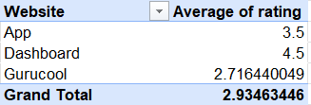
- 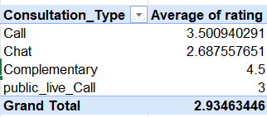

Recommended Allocation of ₹1 Crore:

Investment Area | Budget | Purpose & Target
1. Guru Training | ₹35 lakh (35%) | Train low-rated gurus; target rating 3.5+ for gurus currently in the 0–2 range
2. Technology & Smart IVR | ₹25 lakh (25%) | Improve Gurucool from 2.72 toward 3.50 and reduce failed/busy calls
3. Staffing & Workload Management | ₹20 lakh (20%) | Redistribute workload and reduce extreme loads such as 1,060 calls handled by one guru
4. AI & Customer Support | ₹10 lakh (10%) | Introduce AI chatbot, quick replies and customer-to-guru matching
5. Monitoring & Analytics | ₹10 lakh (10%) | Real-time dashboards and KPI tracking for ratings, workload, call status and revenue

Recommendations:

- Highest Priority – Guru Training: Focus on low-rated gurus and continuously monitor their ratings and call outcomes.
- Technology Upgrade: Improve Smart IVR, call routing and queue management to reduce failed and busy calls.
- Workload Redistribution: Use call volume and call duration to distribute calls more evenly and reduce burnout.
- Improve Chat Support: Introduce AI chatbots and quick responses, especially because chat has a lower rating than calls.
- Continuous Monitoring: Track average rating, failed/incomplete calls, calls per guru, call duration and revenue every month to measure whether the investment is producing improvement.

